Mechanic Guide

Broken Compass Roleplay
v1

How to get the job (for now)
You can get the job at the City Services counter. If you don’t have a vehicle you can /taxi and have it take you to the GPS marker you have. The marker is a white shield seen below.
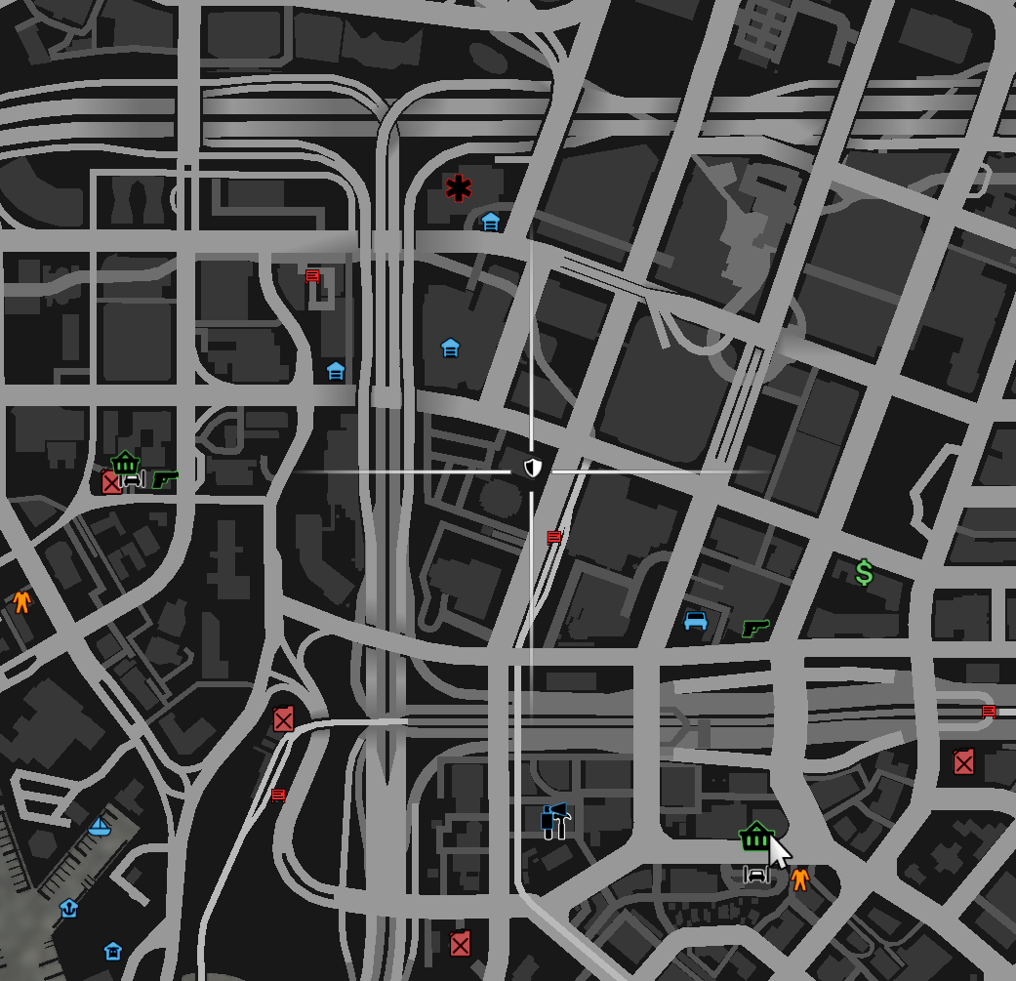

You can always get the job back by coming here should you lose it somehow.

Getting to the Job Area
You can also use /taxi to take you to the job area. You’ll find the job set up around Los Customs in the middle of Los Santos, north from the City Services Counter.
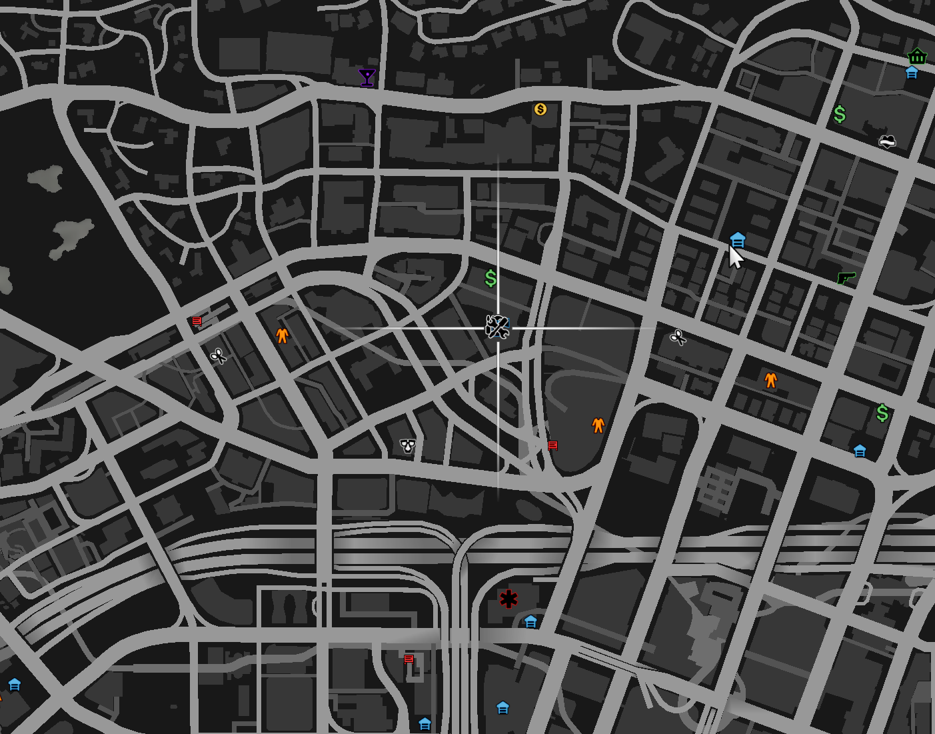
There is also a Los Customs shop set up for people to customize their vehicle there as well as a crafting bench.

Getting a Job Vehicle
The job’s vehicle can be obtained by interacting with these two vehicles with the third eye (hold left ALT) and buying them. This will give you persistent storage and customization options.
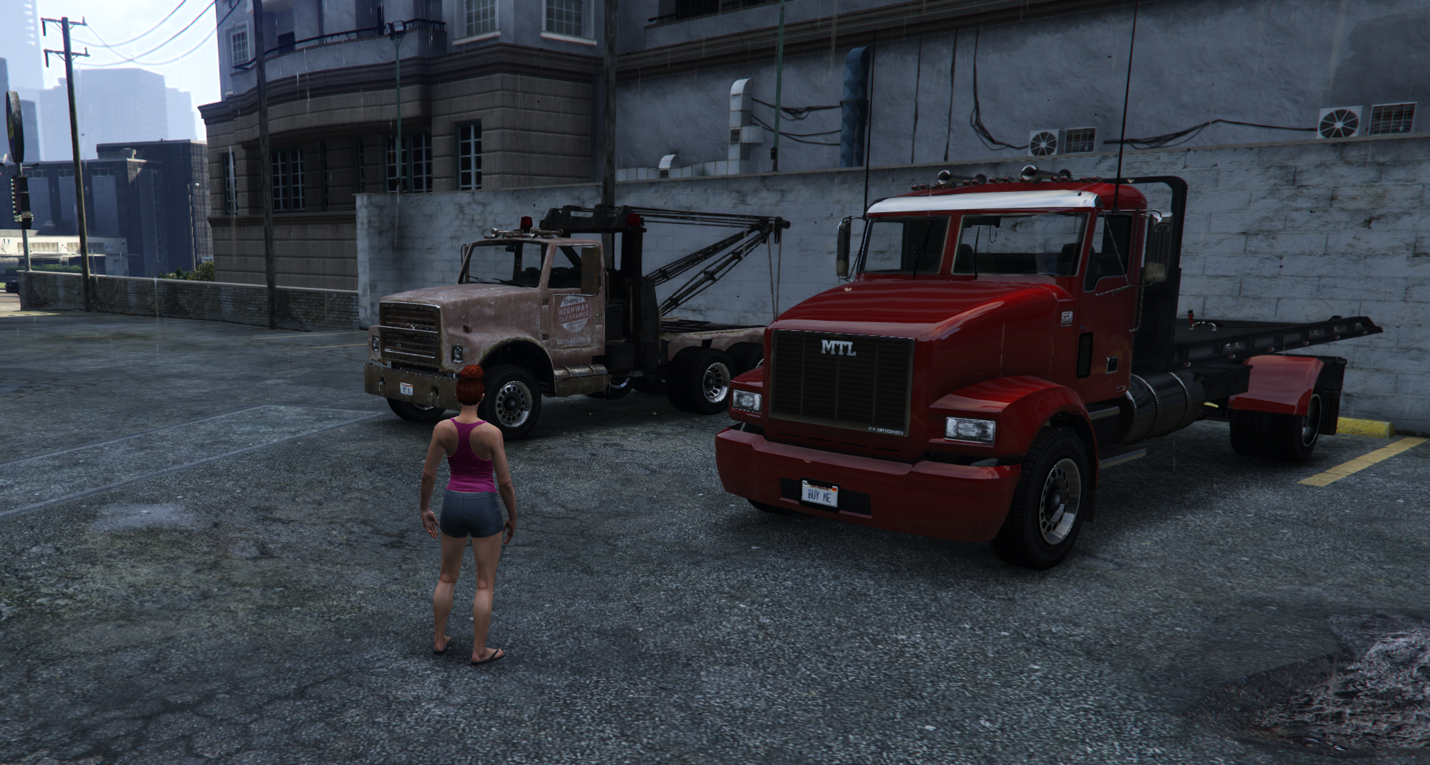

The Job Stash
The job stash is at the back of Los Customs. Target the toolbox with the third eye by holding the left alt key.
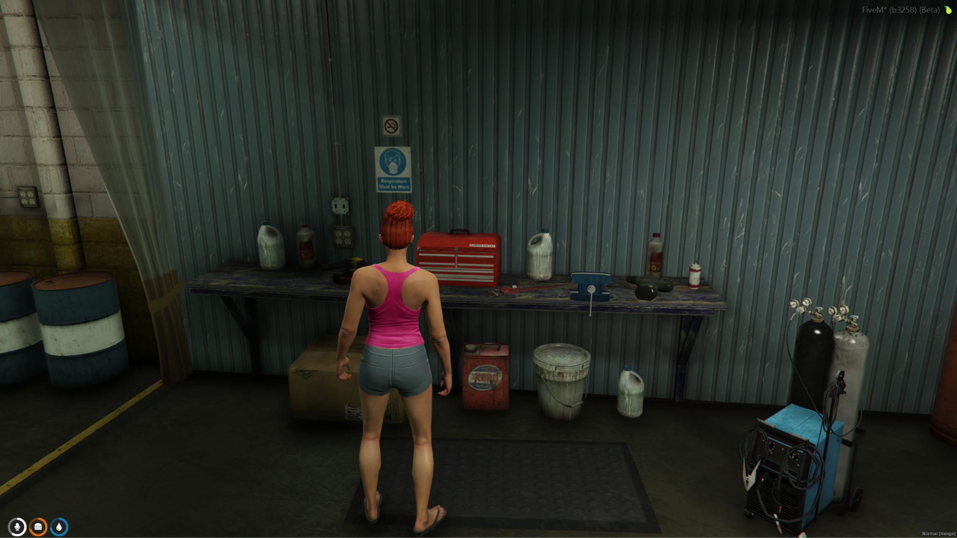

The Job Shop
You can access things you need to make repairs by using the third eye to target a tool chest near a vehicle lift and blue jack.
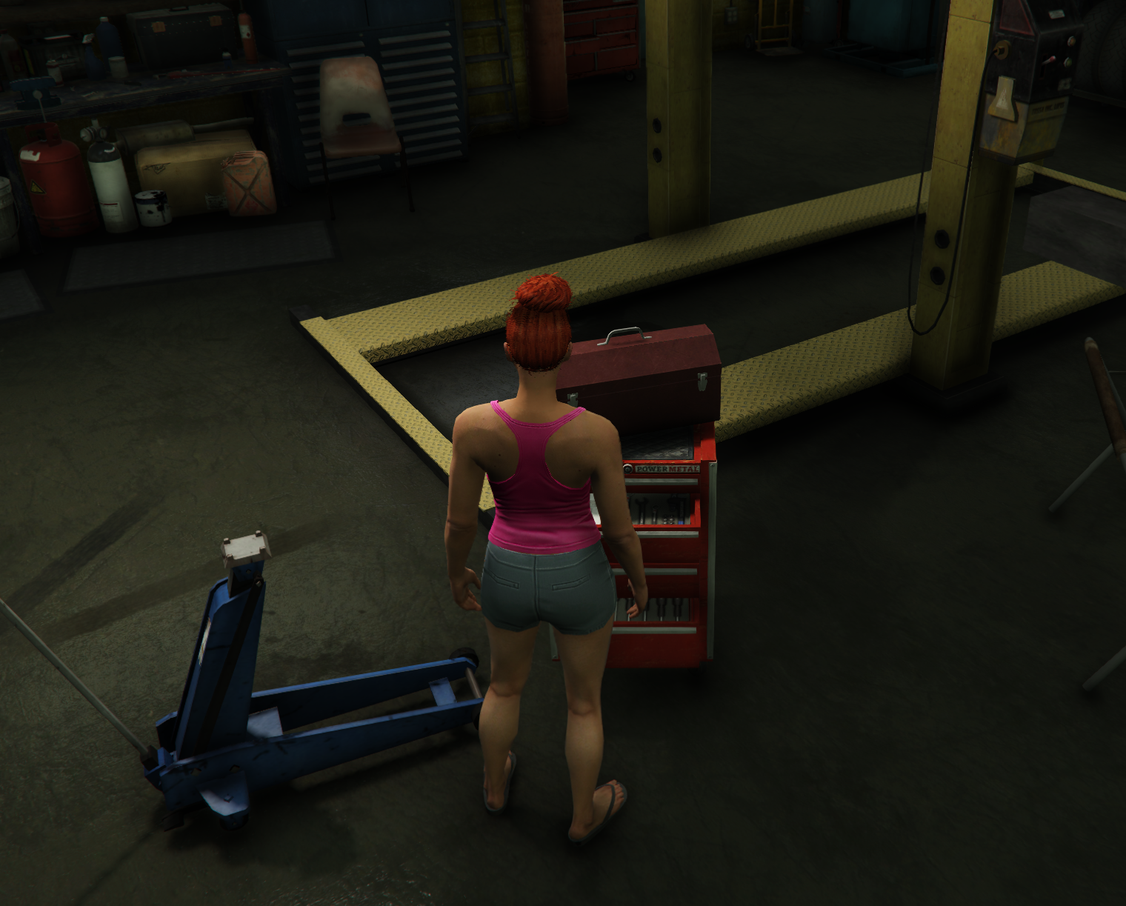

Repairing a Vehicle
You bring a vehicle to the back of the shop and eventually you will get the menu to Work On Vehicle. Use the menu to inspect the vehicle and use the Shop above to get the parts. Also you should have repair kits in the shop to get a vehicle running again. Others have access to the repair kit but you have a minimal cost for the job’s shop.
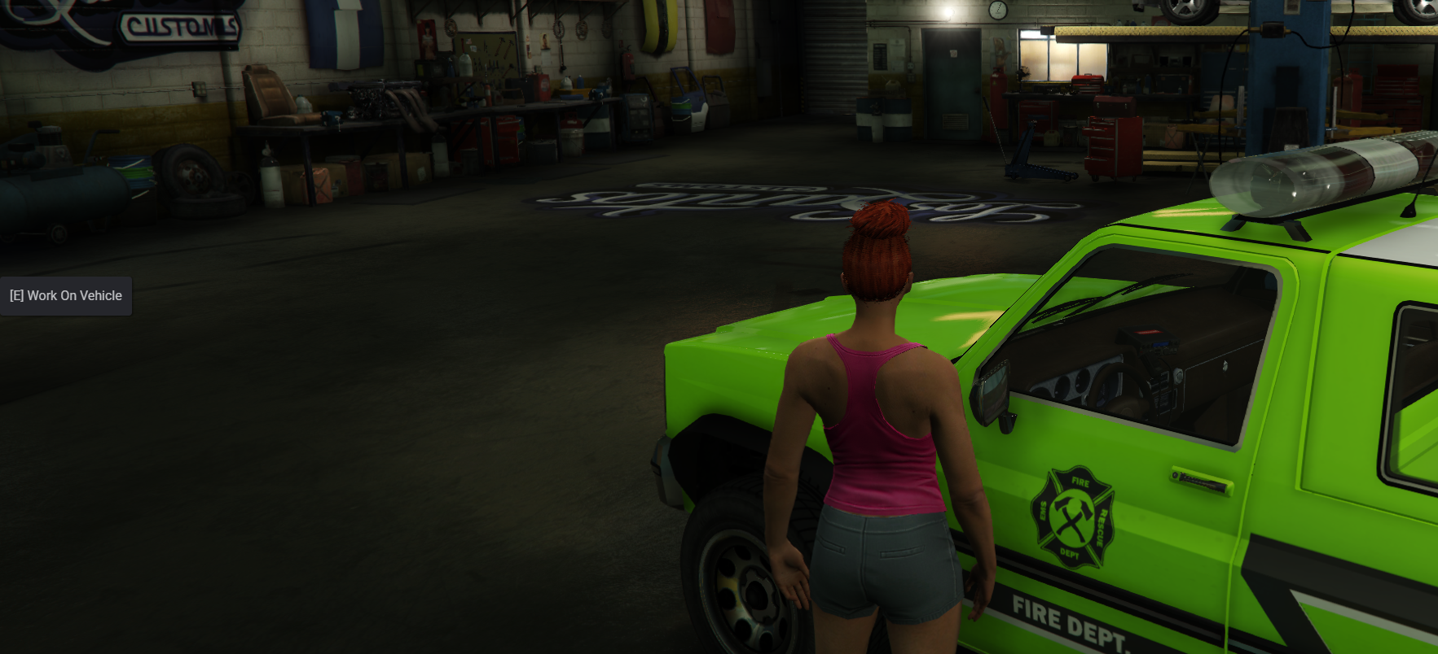

Job Sign Off
You can if you want to go off duty, however you’d need to sign back on to the job at the City Services counter to get the job again, for now. You’ll find the sign off option at the blue office door in the shop.
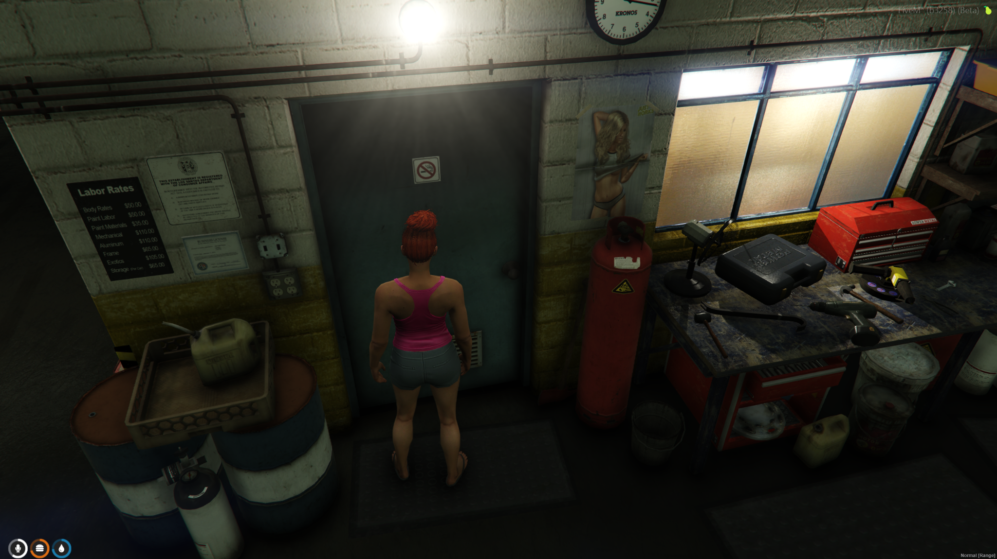

Storing Your Own Vehicle
There is a garage you can access right at Los Customs to store and retrieve the vehicle you purchased.
